Sea Ray 270 – For Sale
“Partnership”
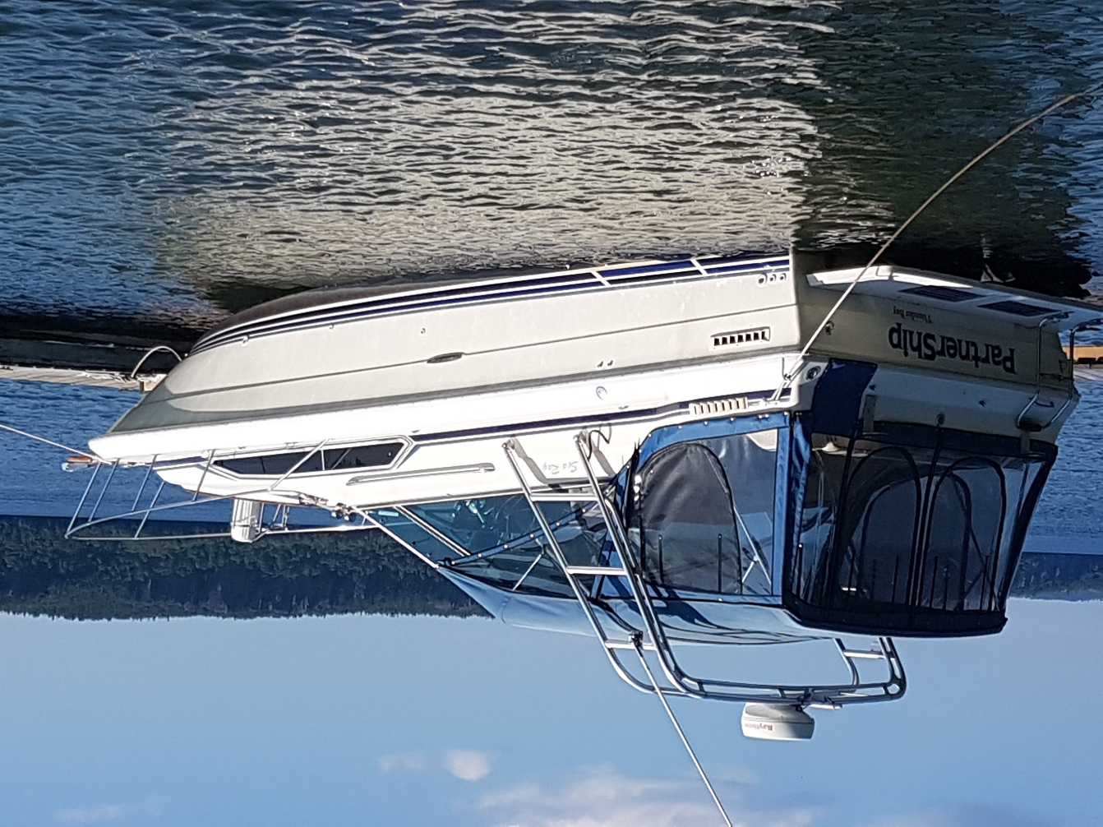

Features
New full canvas top enclosure
Raymarine 24-mile radar on Atlantic Towers arch
Lowrance HDS8 plotter/GPS/Fish Finder
Marine radio
Two large capacity six volt “house” batteries connected in series
Propane stove
Four bilge pumps
Fortress anchor with chain and nylon line

Propulsion
Twin 4.3 litre OMC Cobra’s paired with OMC stern drives
Electronic ignition

Trailer
New Excalibur BT9000 Tri Axle Boat Trailer

Asking - $25,000
Contact: Porter Bailey – porter.bailey@gmail.com or (807) 474-1740
Sea Ray 270 – For Sale
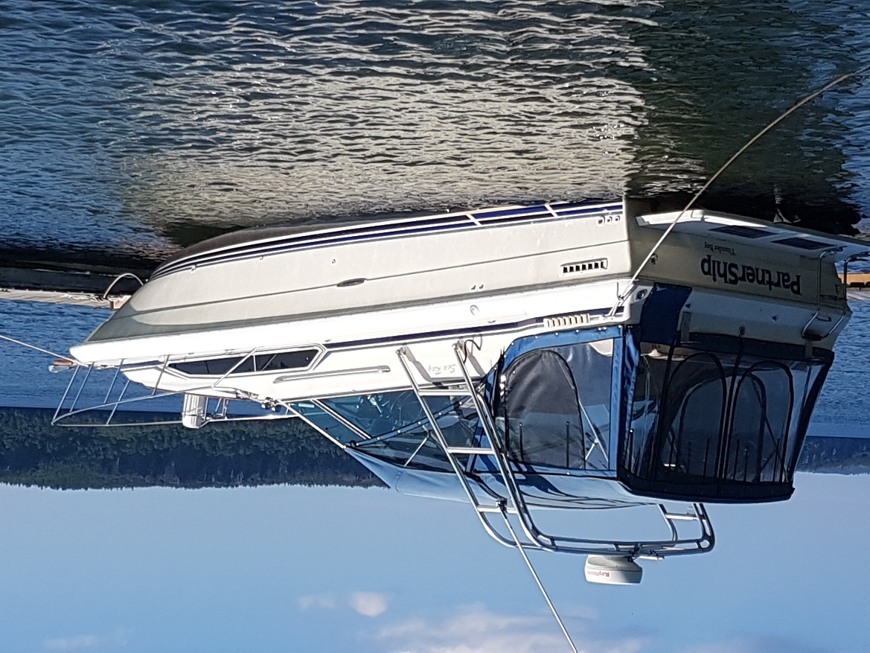

Excellent cruising boat with accommodation for up to six. Used extensively on Lake Superior including Isle Royale and the North Shore. Comfortable accommodation with numerous features to support fishing and general cruising.

Details
Model – 27’ Sundancer AC
Length – 27 ft. plus swim platform
Beam – 10 ft.
Built - 1986
HIN – SERT 3740D686 270DA 1569
Registration # - 60E17220

Power – Twin OMC Cobra 4.3L, V6, with two Stern Drives
Fuel Capacity – 100 US gallons
Maximum speed >28 mph
New battery charger
Trim Tabs – Bennett electric/hydraulic trim tabs

Electronics - Lowrance HDS8 plotter/GPS/Fish Finder, Raymarine 24-mile radar on Atlantic Towers arch

Overnight accommodation for six, with forward V-berth, mid-berth and rear sleeping quarters.

Trailer – New Excalibur BT9000 included.

Asking - $25,000
Contact: Porter Bailey – porter.bailey@gmail.com or (807) 474-1740

